HISTORY & SYSTEMS OF PSYCHOLOGY
PSYC 3100 sec 001 Spring 2019
Mon Wed 4:40-5:55
GENT 131

Eric Lundquist
Office: BOUS 136
Phone: (860) 486-4084
Office Hours: Mon Wed 6:00-7:00
and by appointment

E-mail: Eric.Lundquist@UConn.Edu

Web Page:
http://web9.uits.uconn.edu/lundquis/history.html

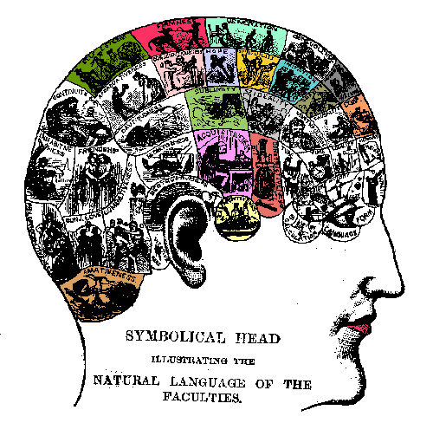

READING:
1. REQUIRED: Hergenhahn, B.R. (2009). An Introduction to the History of Psychology 6th ed. Belmont, CA: Wadsworth. ISBN 9780495506218; OR 7th ed. ISBN 9781133958093
2. REQUIRED: On-Line Readings and Reserve Readings (to be announced)
3. OPTIONAL: Papers linked at http://psychclassics.yorku.ca/

GRADING:
Two Quizzes: 30% approximately 5th and 12th weeks of class (Wed 2/20, Wed 4/17)
Midterm: 35% approximately 10th week of class (Wed 4/3)
Final: 35% TBA AS SCHEDULED BY THE REGISTRAR

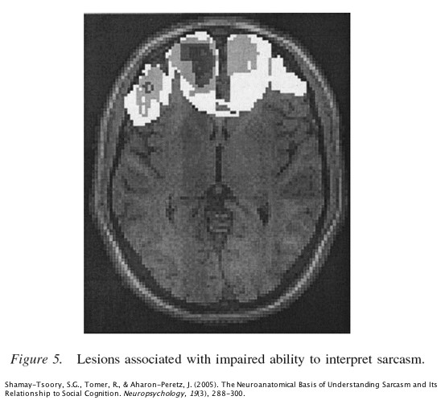

Readings in Hergenhahn 6th edition (see web page for readings in 7th edition):
THE HISTORY AND SYSTEMS OF PSYCHOLOGY COURSE
* schools of thought in the first decades of psychology [web page]
SCIENTIFIC MATERIALISM AND PSYCHOLOGY
* cortical localization of function: Franz Joseph Gall and phrenology (pp. 244-247), Phineas Gage, Paul Broca
* contemporary approaches to the mind in psychology: Cognitive Neuroscience; Parallel Distributed Processing a.k.a. Neural Networks or Connectionism (CH.20: pp. 635-639 on New Connectionism) and its antecedents [PDP History web page]
PSYCHOLOGY AS A NATURAL SCIENCE: FOUR DEFINITIONS
* textbook definition (overview of psychology's history): CH.20 pp. 623-628 on the birth of cognitive psychology, p. 616 on Chomsky; see also "Early Psychology" readings for structuralism and behaviorism
* natural science definition
* philosophical definition: CH.1 pp. 18-23 empiricism, nativism, and rationalism
* practical definition (extensional definition)
* implications of definitions for the materialist scientific world view
EARLY PSYCHOLOGY
* Mueller pp. 235-236 ("Doctrine Of Specific Nerve Energies")
* Helmholtz pp. 237-242 ("Helmholtz's Stand Against Vitalism"; "Rate Of Nerve Conduction" through "Helmholtz's Contributions")
* Weber pp. 251-252 (esp. "Judgments are relative")
* Fechner pp. 254-256 ("Psychophysics")
* Donders pp. 269 ("Mental Chronometry" - in the middle of the Wundt section)
* Wundt and voluntarism: pp. 262-264; 266-267 ("Psychology's goals"; "Mediate and immediate experience"; "Wundt's use of introspection"); 268-270 ("Mental chronometry"); 271-272 ("Volitional Acts"; "Volkerpsychologie"; "The Historical Misunderstanding of Wundt")
* Titchener and structuralism: pp. 275-277 ("Psychology's goals"; "Titchener's use of introspection"; "Mental elements"; "Law of Combination"), 277-278 ("The decline of structuralism")
* Kulpe and the imageless thought debate: pp. 283-285
* Watson and the founding of behaviorism: p. 401 (quote), 404-405 ("Language and Thinking"), 407-408 ("Watson's experiment with Albert"), 411-412 ("the mind-body problem"; "Watson's influence")
* Functionalism: pp. 336-337 ("Stage Four: US Functionalism"; "Characteristics of Functionalistic Psychology"); 376 ("The Fate Of Functionalism")
THE MIND-BODY PROBLEM AND ITS RELATION TO PSYCHOLOGY
* dualism: substance dualism (interactionist / Cartesian, popular); property dualism (epiphenomenalism, interactionist property dualism, elemental property dualism)
* monism: idealism, materialism (philosophical behaviorism, reductive materialism / identity theory, functionalism)
* Mind-Body Problem web page; CH.1 pp. 17-19 mind-body problem (secondary to the Mind-Body Problem web page); CH.20 pp. 628-635 on Artificial Intelligence, Turing, Searle, Information-Processing Psychology; pp. 633-634 "The Return Of The Mind-Body Problem"
PHILOSOPHY OF SCIENCE
* CH.1 pp. 7-14 "What Is Science", Logical Positivism, Popper and Kuhn; pp. 14-17 determinism
FOUNDATIONS OF ONTOLOGY AND EPISTEMOLOGY IN EARLY GREEK PHILOSOPHY
* CH.2: pp. 29-38 on Thales, Anaximander, Heraclitus, Parmenides, Pythagoras, Empedocles, Democritus; pp. 38-41 on Early Greek Medicine; pp. 41-60 on the Sophists, Socrates, Plato, and Aristotle
* Freud and Plato: pp. 531-532 on id, ego, and superego; pp. 527-528 and 534-536 on the Oedipus Complex and its resolution in the "phallic stage" of psychosexual development
* Mapping Aristotle's Four Causes onto behaviorist theories of learning: Lashley and material cause, p. 607; Hull and efficient cause, pp. 435-437 (esp. section on "Reaction Potential"); Tolman and formal cause, pp. 430-431; Skinner and final cause, p. 445 (section on "Operant Behavior") and p. 448 (section on "Skinner's Attitude Toward Theory")
THE SCIENTIFIC REVOLUTION
* Augustine pp. 78-79 (top)
* Scholasticism p. 86
* Thomas Aquinas pp. 89-91
* Galileo pp. 108-112
* Newton pp. 112-114
FOUNDATIONS OF MODERN EPISTEMOLOGY
* Descartes pp. 117-124
* John Locke pp. 134-140
* George Berkeley pp. 140-143
* David Hume pp. 143-150
* Immanuel Kant pp. 192-196
* Platonic and Aristotelian themes in psychology [Epistemology web page]
POSITIVISM
* Auguste Comte's version pp. 168-169 and Ernst Mach's version pp. 171-172; William Of Occam, pp. 91-92; Francis Bacon, pp. 115-117; B.F. Skinner, p. 444
* Logical Positivism and Neobehaviorism pp. 423-426
* Logical Positivism web page
MENTAL TESTING
* CH.10 pp. 302-326
* Franz Joseph Gall and phrenology pp. 244-247
* Maskelyne, Kinnebrook, Bessel on reaction time and personal equations pp. 232-233
PSYCHOANALYSIS
* CH.16

