HISTORY & SYSTEMS OF PSYCHOLOGY
PSYC 3100 sec 03 Spring 2009
Mon Wed Fri 1:00-1:50
ARJ 215

Eric Lundquist
Office: BOUS 136
Phone: (860) 486-4084
Office Hours: Mon Wed 4:00-5:00,
and by appointment

E-mail: Eric.Lundquist@UConn.Edu

Web Page:
http://vm.uconn.edu/~lundquis/history.html

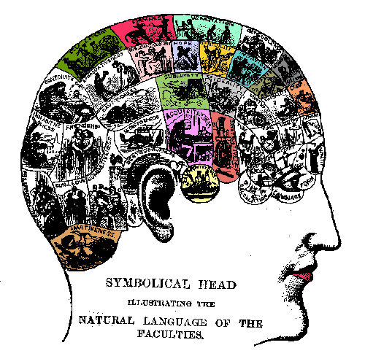

READING:

1. REQUIRED: Hergenhahn, B.R. (2005). An Introduction to the History of Psychology (5th ed.). Belmont, CA: Thomson Wadsworth. (ISBN: 0534554016)
2. REQUIRED: On-Line Readings and Reserve Readings (to be announced)
3. OPTIONAL: Papers linked at http://psychclassics.yorku.ca/

GRADING:

Two Quizzes: 30% approximately 5th and 12th weeks of class (Fri 2/20, Fri 4/17)
Midterm: 35% approximately 9th week of class (Fri 3/27)
Final: 35% SATURDAY MAY 9, 10:30 AM

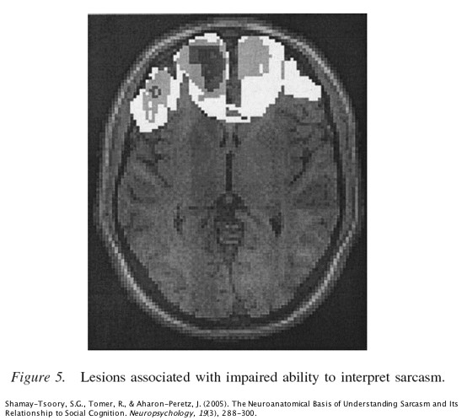
[over -->]
TOPICS AND THEMES
Psychology As Natural vs. Social Science
Empiricism & Associationism vs. Rationalism & Nativism
Scientific Materialism
Overview Of History Of Psychology: 1879, 1913, 1967
The Mind-Body Problem and Contemporary Cognitive Psychology
Philosophy Of Science: Logical Positivism, Popper, Kuhn
Origins Of Ontology And Epistemology In Greek Thought
Modern Epistemology: Descartes, Locke, Berkeley, Hume, Kant
Tributaries Of Psychology: Associationism, Positivism, Physiology, Mental Testing, Statistics
Schools Of Psychology: Voluntarism, Structuralism, Functionalism, Behaviorism, Cognitivism

READINGS (subject to expansion and revision)
INTRODUCTION:
* CH.1: pp. 5-12 "What Is Science", Logical Positivism, Popper and Kuhn; pp. 12-15 determinism; pp. 15-17 mind-body problem (replaceable by the Mind-Body Problem web page); pp. 16-20 empiricism, nativism, and rationalism
CONTEMPORARY COGNITIVE PSYCHOLOGY:
* CH.20: pp. 571-576 overview of the birth of cognitive psychology. (Also relevant are pp. 564-565 on Chomsky.); pp. 576-585 on Artificial Intelligence, Turing, Searle, Information-Processing Psychology, and New Connectionism; p. 580 "The Return Of The Mind-Body Problem"
EARLY GREEK PHILOSOPHY:
* CH.2: pp. 26-34 and 37-54 on Thales, Anaximander, Heraclitus, Parmenides, Pythagoras, Empedocles, Democritus; the Sophists; Socrates, Plato, and Aristotle
* Freud and Plato: pp. 487-489 on id, ego, and superego; pp. 484-485 and 491-492 on the Oedipus Complex and its resolution in the "phallic stage" of psychosexual development
* Mapping Aristotle's Four Causes onto modern theories of learning: Lashley and material cause, p. 557; Hull and efficient cause, p. 398 and p. 399 (section on "Reaction Potential"); Tolman and formal cause, pp. 393-394; Skinner and final cause, p. 407 (section on "Operant Behavior") and p. 409 (section on "Skinner's Attitude Toward Theory")
FOUNDATIONS OF MODERN EPISTEMOLOGY:
* Descartes pp. 106-112
* John Locke pp. 121-126
* George Berkeley pp. 126-129
* David Hume pp. 129-135
* Immanuel Kant pp. 175-178
* Platonic and Aristotelian themes in psychology (epistemology web page)
THE SCIENTIFIC REVOLUTION:
* Augustine pp. 70-71(top)
* Scholasticism p. 77
* Thomas Aquinas pp. 81-82
* Galileo pp. 97-100
* Newton pp. 100-102
POSITIVISM:
* Auguste Comte's version pp. 153-154 and Ernst Mach's version p. 156; William Of Occam, pp. 83-84; Francis Bacon, pp. 103-105; B.F. Skinner, p. 406
* Logical Positivism and Neobehaviorism pp. 387-390
EARLY PSYCHOLOGY:
* Helmholtz pp. 216-220 ("Rate Of Nerve Conduction" through "Helmholtz's Contributions")
* Weber pp. 229-230 (esp. "Judgments are relative")
* Fechner pp. 232-233 ("Psychophysics")
* Donders pp. 246 ("Mental Chronometry" - in the middle of the Wundt section)
* Wundt and voluntarism: pp. 240-241; 243-245 ("Psychology's goals"; "Mediate and immediate experience"; "Wundt's use of introspection"); 246-247 ("Mental chronometry"); 248-49 ("Volitional Acts"; "Volkerpsychologie"; "The Historical Misunderstanding of Wundt")
* Titchener and structuralism: pp. 252-253 ("Psychology's goals"; "Titchener's use of introspection"; "Mental elements"; "Law of Combination"), 254 ("The decline of structuralism")
* Kulpe and the imageless thought debate: pp. 259-261
* Watson and the founding of behaviorism: p. 367 (quote), 370-371 ("Language and Thinking"), 372-374 ("Watson's experiment with Albert"), 376-377 ("the mind-body problem"; "Watson's influence")
* Functionalism: pp. 308-309 ("Stage Four: US Functionalism"; "Characteristics of Functionalistic Psychology"); 344-345 ("The Fate Of Functionalism")
MENTAL TESTING:
* CH.10 pp. 277-299
* Franz Joseph Gall and phrenology pp. 223-224
* Maskelyne, Kinnebrook, Bessel on reaction time and personal equations p. 211
PSYCHOANALYSIS:
* CH.16

