QUANTITATIVE METHODS
IN THE BEHAVIORAL SCIENCES
STAT 379:01 Spring 2008
Mon Wed 10:00-11:30
BOUS 160

Eric Lundquist
Office: BOUS 136
Phone: (860) 486-4084
Office Hours: Mon Wed 4:00-5:00,
and by appointment
E-mail: Eric.Lundquist@UConn.Edu
Web Page: http://cliff.uconn.edu/stat379.html

Teaching Assistants and Office Hours:
Donald Edmondson, BOUS 212
Tue 1:00-3:00 and by appointment
E-mail: Donald.Edmondson@UConn.Edu
Carissa Gross, BOUS 366
Fri 12:00-2:00 and by appointment
E-mail: Carissa.Gross@UConn.Edu

Galton, Francis (1886). Regression towards mediocrity in hereditary stature. Journal of the Anthropological Institute 15, 246-263.
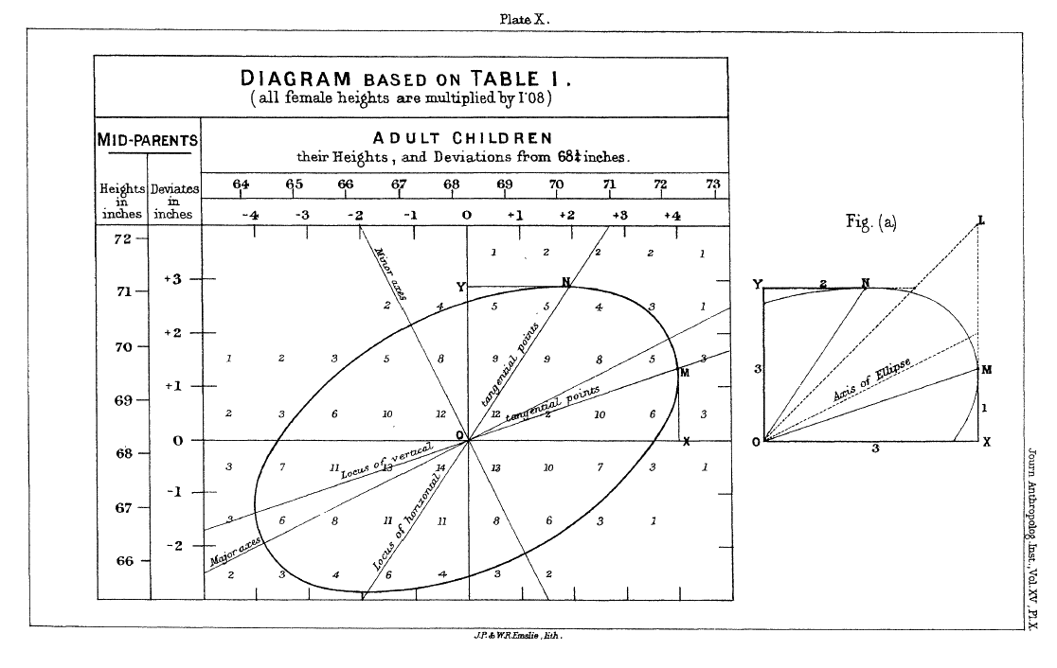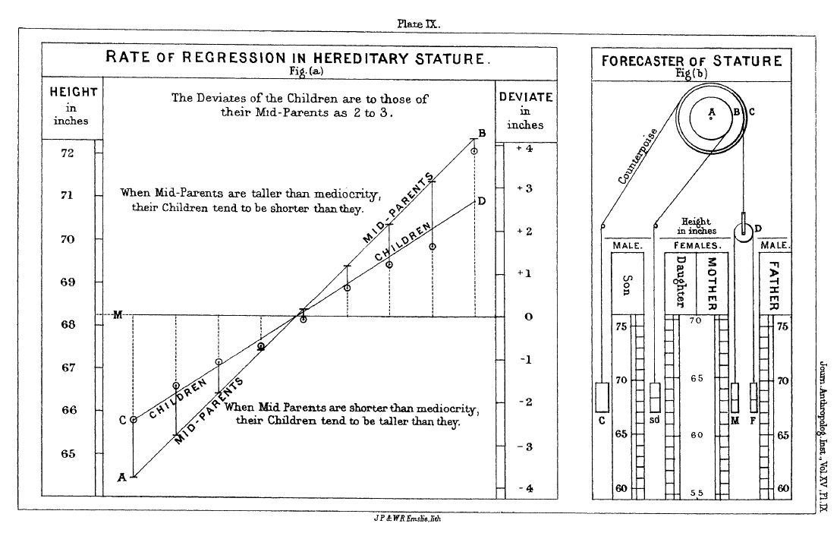

READING:
1. Keith, Timothy Z. (2006). Multiple Regression And Beyond. Allyn & Bacon. ISBN: 0205326447
(ISBN-13: 9780205326440)
Textbook Web Page with data sets for exercises: http://www.ablongman.com/keith1e
2. Grimm, Lawrence G. and Yarnold, Paul R. (1994). Reading and Understanding Multivariate Statistics. APA. ISBN: 1-55798-273-2 (ISBN-13: 978-1-55798-273-5)
3. On-Line Readings and Reserve Readings (to be announced)

GRADING:
Homework: 30% assigned weekly
Midterm: 35% WEDNESDAY MARCH 5, 10:00 AM
Final: 35% WEDNESDAY MAY 7, 10:00 AM

Introduction K 491-510
Correlation K 499-505
Simple Regression K Ch. 1
Multiple Regression: two predictors K Ch. 2
Multiple Regression: more on the two-predictor case K Ch. 3
Multiple Regression: the general case K Ch. 4; K Ch. 5 pp. 96-97
Multiple Regression: simultaneous, sequential, and stepwise K Ch. 5
Multiple Regression: categorical predictors K Ch. 6
Multiple Regression: categorical and continuous predictors K Ch. 7
ANCOVA K Ch. 7 pp. 155-156
Multiple Regression: interactions with continuous variables K Ch. 8
Multiple Regression: assumptions, diagnostics, other issues K Ch. 9
Logistic Regression GY Ch. 7; K pp. 205-207
Principal Components / Factor Analysis GY Ch. 4; K pp. 305-306
MANOVA GY Ch. 8
Discriminant Function Analysis GY Ch. 9
Canonical Correlation Grimm and Yarnold (2000)
Multiway Frequency Analysis GY Ch. 6
Path Analysis / Structural Equation Modeling K Ch. 10 and 11; GY Ch. 3

