STAT 3115Q Homework 9 Due Friday, November 30th

1. The figures below show the population means for six experiments. For each one indicate whether an A effect, a B effect, and an AxB interaction is present.

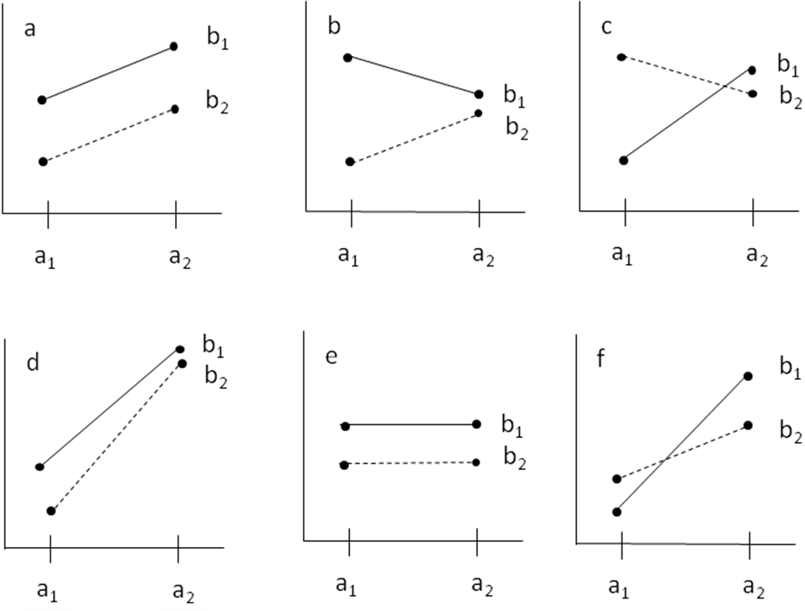

2. In a classical conditioning study inspired by Wilcoxon, Dragoin, and Kral (1971), the effectiveness of two predictors of illness on two animal species was studied. Rats and quail were given water that was both blue-colored and sour-tasting, followed shortly by poison-induced illness. How well the animals learned each predictor was measured by how much they subsequently avoided each predictor in isolation. The test conditions were (1) water that was blue-colored but normal tasting and (2) water that was clear but sour-tasting, and drinking amounts were averaged for rats and quail separately. Each animal was tested on only one predictor; there were eight animals in each cell. The dependent measure was "percent of baseline drinking amount" so strong avoidance corresponded to a low percentage of the initial amount of drinking.
a) Construct a tree diagram with a1 and a2 as "species" and b1 and b2 as "predictor".
b) What are the degrees of freedom for each main effect and for the interaction? (Show how you got them.)
c) Mean "percentage of baseline drinking amount" is reported for each group in the following table. Make a graph of the means (no SPSS required) and interpret it in terms of the simple effects, main effects and interaction (assuming all observed differences to be statistically significant).

 | color | taste
Rats | 90 | 35
Quail | 20 | 95

3. Define the following in words:
a) Simple effect
b) Main effect
c) Interaction

4. The data set HW9f12.sav is from a study that assesses the job satisfaction of two types of Elvis-impersonators: Elvis Presley-impersonators and Elvis Costello-impersonators (factor A). We have selected Elvis-impersonators who have been on the job for varying numbers of years: 5, 10, 15, and 20 (factor B). The dependent variable is a composite measure of satisfaction with the job and satisfaction with the wardrobe. Note that although this dataset is (by amazing coincidence) superficially similar to that of Homework 7, all cells in the present study have equal n's.
a) Run an ANOVA on “HW9f12.sav” and construct the standard ANOVA table (SV, df, SS, MS, F, and p) and report whether the p-value is significant for each effect. Levene's test for homogeneity of variance will be significant, indicating violation of the assumption, but you should blithely proceed with the analysis (and those in question 5) as if all were well.
b) Estimate the complete omega squared ω²_{B} for the B effect of years on the job, using equation 11.20 in Keppel and Wickens (sorry no hat on my ω² here but there should be one for this sample-based version).
c) Estimate the partial omega squared ω²_{<B>} (unfortunately hatless again) for the B effect of years on the job, using equation 11.22 in Keppel and Wickens.
d) Distinguish between the complete omega squared and the partial omega squared as measures of effect size.
e) What would SS_{S/A} (the error SS) be if this study were run without factor B, i.e., if groups were only identified by "Elvis type"? (You don't need to re-analyze the data that way to answer this question, but if you DO do it that way, you should explain what the relationship is between the SS's for the two analyses rather than just mindlessly reporting the output -- then at least you'll see why you didn't need to re-run it!)

5. To understand the interaction, perform both a simple effects analysis and an interaction contrast analysis on this dataset.
a) Simple effects: Is there a significant simple effect of years on the job for Elvis Presley-impersonators? For Elvis Costello-impersonators? Report the F, df, and p for each test. Interpret these results.
Use a filter to first select only the cases for which Elvis type = Presley and perform the one-factor ANOVA using years of experience as the factor. Do the same for Elvis type = Costello. In each case you will obtain a full ANOVA table, but you will ignore the F-ratio and only note the MS_{effect} (where the effect of interest is years on the job) in each analysis. To get the accurate F-ratio, you have to divide (by hand!) each MS_{effect} by the omnibus analysis's error term MS_{S/AB} and then compare it to the tabled value of F on (df_{effect} , df_{S/AB}).
b) Interaction contrasts: At how many years on the job do the simple effects really diverge significantly? There are various sets of cells we could test to investigate this question; let's choose to test the interaction of years on the job and Elvis type for just the 5 and 15 year groups; then test the same interaction for the 10 and 20 year groups. Report the F, df, and p for each test. Interpret these results.
Use a filter to first select only the cases for which "years = 5 or years = 15" and perform the two-factor ANOVA on those data. Do the same for the cases for which "years = 10 or years = 20". In each case you will obtain a full ANOVA table, but you will ignore the F-ratio and only note the MS_{effect} (where the effect of interest is the interaction) in each analysis. To get the accurate F-ratio, you have to divide (by hand!) each MS_{effect} by the omnibus analysis's error term MS_{S/AB} and then compare it to the tabled value of F on (df_{effect} , df_{S/AB}).
c) Which of the component(s) of the analysis identified in (a) and (b) seem to account for the significant omnibus type*years interaction?

