PSYC 5104 Homework 8 Due Friday, November 16th

The data set HW8f18.sav is from a study that assesses the effect of antidepressant drugs on happiness ratings among adults, children and adolescents. The data set has divided participants into ‘adults’ who are over 18 and ‘non-adults’ who are under 18. They receive a dosage of either 5, 10, 15, or 20 mg. We have two independent variables -- age group and drug dosage -- and a dependent variable which is a rating of happiness (combined self-report and therapist assessment).

First examine the two independent variables together, as a two-factor ANOVA design.

1a. Produce an ANOVA table that includes df, SS, MS, F and p for both variables and their interaction.
Running a multiple factor ANOVA is straightforward. Go to Analyze -> GLM -> Univariate and set it up just like we did for a single factor experiment, except that we'll enter both IVs as Fixed Factors. You can enter as many IVs as you want and SPSS will automatically include all interactions. You should also routinely (by now) click on 'Options' and ask for 'Descriptives', 'Homogeneity Tests (even though you should proceed with this exercise regardless of violating the homogeneity of variance assumption)', and 'Estimates Of Effect Size' to get "partial eta-squared".

1b. Is each main effect significant and is the interaction significant?

1c. Produce a line plot of the dosage means that distinguishes between age groups.
The best way to do this is from the Univariate ANOVA window. Click the 'Plots' button, then put the dosage level on the horizontal axis and age group as separate lines. (This will be easier to read than doing the reverse, since this way there will only be two separate lines instead of the four you'd get if they represented dosages; the information in either version of the plot would be identical though -- try it and see.) Click 'Add' and your plot will appear in the list. Click 'continue' and then 'okay' to get your output with the plots. Again, having Descriptives might help you to interpret this, but it’s not strictly necessary. You could also get the graph from Graphs -> Legacy Dialogs -> Line; the end result is the same, but it's an extra step instead of just clicking an option within GLM Univariate.

1d. Show how "partial eta-squared" for each main effect and the interaction is calculated from the output's SS values.

1e. Interpret your findings, addressing both potential main effects and the interaction.

2. The figures below show the population means for six experiments. For each one indicate whether an A effect, a B effect, and an AxB interaction is present. (In (d) the two a1 means are both meant to appear above the "a1" label, forgive the sloppy graphics!)

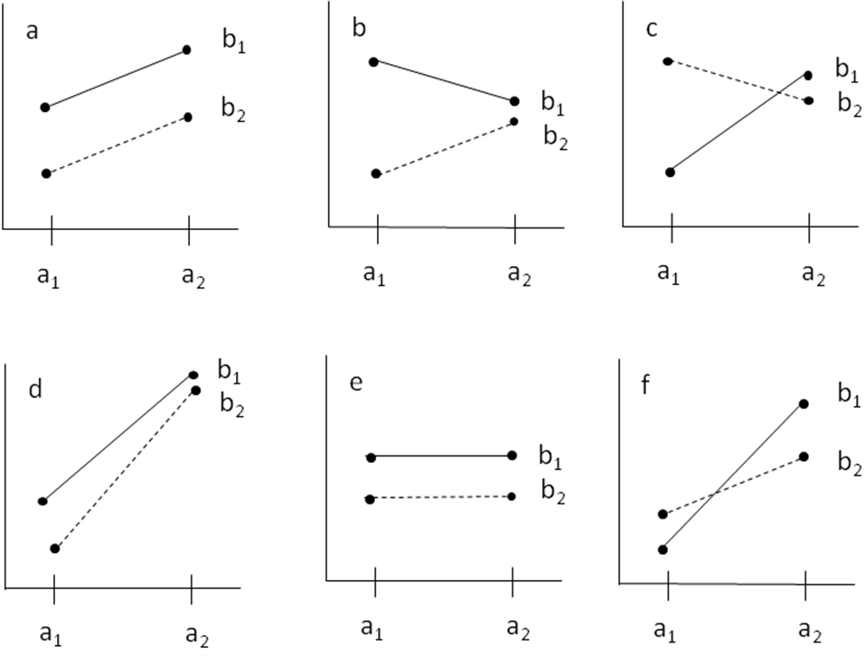
OPTIONAL TREND ANALYSIS
We only give trend analysis a cursory overview in class, but for your edification and possible future reference (and understanding of the concept on the final exam), you can OPTIONALLY go through these steps in SPSS and see how the results fit together and could be interpreted. From the data set HW8f18.sav used in question 1, consider a trend analysis on the dosage variable (ignoring age) to see if there is a linear relationship between dosage and happiness or if that function is something more complex.

3a. Produce a modified ANOVA table reporting the df, SS, MS, F and p for linear, quadratic, and cubic trends (and the error term) similar to the table below:

SV | df | SS | MS | F | p
A linear
A quad
A cubic
S/A

The easiest way to test for nonlinear trends in SPSS is to use the One-Way ANOVA. Go to Analyze -> Compare Means -> One-Way ANOVA. Enter dosage as the factor and happiness score as the DV, then click on ‘Contrasts’. Check the ‘Polynomial’ box at the top and select the highest "degree" polynomial contrast you want from the pull-down menu (we want to go up to cubic; nothing higher will work because we run out of degrees of freedom). No further coefficients need to be filled in manually. The ANOVA output will include information on the various contrasts of different degrees (i.e., 1st=linear, 2nd=quadratic, 3rd=cubic), which is the part of the output to use to make the table above; it also includes tests of the "deviations" for each contrast, except the last one. The deviations are tests of the residual variability (called SS_{failure} in K&W), i.e., what part of the SS_{A} is leftover after we've examined each trend contrast in succession. This could tell us if we should continue to look for a higher order trend to explain that remaining variability, but once we go as high as our degrees of freedom allow we will have accounted for all of SS_{A} and there will be no more residual variability (hence no deviation for the final contrast). Deviations do not need to appear in your table.
Under 'Options' you should also click on 'descriptives' and 'homogeneity of variance test', and 'means plot'. This will show you that the standard deviations (and therefore variances) differ quite a bit, significantly so in fact. In real life you might choose to apply a square root, log, or other transform to the DV to address this problem. But proceed without doing that since this is demonstration and not real life. The means plot might indicate to you the general shape of your trend, so you can judge whether it's useful to test the trend's significance.

3b. Are any of the trends significant? Are you surprised, given the significance of the A effect overall?

3c. What is the relationship between the numerical SS_{A} and the SS's for the orthogonal trend contrasts? Likewise for the numerical df_{A} and the df's for the contrasts? And likewise for the respective MS's and F's? (Note: these relationships hold among any set of orthogonal contrasts.)

3d. What kind of trend does the dosage data appear to suggest, based on the means plot? Note that the number of directions of the slope gives the "degree" (first, second, third...) of the polynomial: e.g., a downward slope followed by an upward slope would imply a quadratic trend (y=x², second degree), while a downward followed by upward followed by another downward would imply a cubic trend (y=x³, third degree).

3e. What kind of trend does the dosage data appear to BEST fit (regardless of significance), based on the proportion of SS_{A} being accounted for? Compare SS_{linear} / SS_{A} , SS_{quadratic} / SS_{A} , and SS_{cubic} / SS_{A} , analogous to how R² describes the proportion of TOTAL variability being accounted for by the A treatment.

